**ACCOMMODATION RECOMMENDATIONS**

**Copenhagen Business School  
  
SAS Radisson Blu**

Falkoner Alle 9

2000 Frederiksberg

+ 45 38 15 80 01

www.radissonblu.com/falconerhotel-copenhagen

[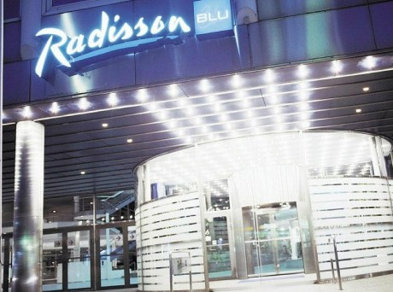](http://www.google.dk/url?sa=i&rct=j&q=&esrc=s&frm=1&source=images&cd=&cad=rja&uact=8&docid=b7NZO_Zztmx3lM&tbnid=08sazyuHXTG-sM:&ved=0CAUQjRw&url=http://falkoneralle-shopping.dk/butik/radison-blu-falconer-hotel-3993.html&ei=-S17U4niPKWYyAPTjoDQBw&bvm=bv.67229260,d.bGQ&psig=AFQjCNHvt7Z7UKjsBJGG9b9tuvLde6IUlw&ust=1400667940207356)

“The hotel in stunning Copenhagen is ideally located near attractions and near the CBS Campus. Guests at this hotel can easily explore Copenhagen and its many attractions, including Tivoli Gardens and the National Gallery. Blend in with the locals by renting a bicycle in one of the world’s most bike-friendly cities, and traverse the cobblestone streets and historic canals with ease. The hotel is only a 5 minutes’ walk from CBS. The hotel and the Frederiksberg metro stop, with its direct connection to the airport, are only 200 meters apart, providing the ultimate convenience to travelers. From the airport, take the Metro toward Vanløse (only one line). Disembark after 20 minutes at Frederiksberg station.”

**Hotel The Square**

Rådhuspladsen 14

1550 Copenhagen V

+45 33 38 12 00

www.thesquare.dk

[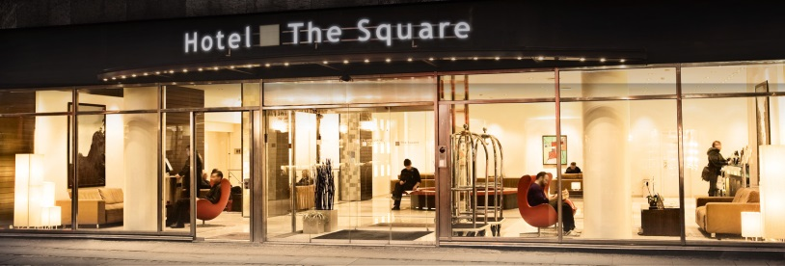](http://www.google.dk/url?sa=i&rct=j&q=&esrc=s&frm=1&source=images&cd=&cad=rja&uact=8&docid=-dLzNy_aarZOiM&tbnid=m-Rn6PqhSPhPVM:&ved=0CAUQjRw&url=http://www.arp-hansen.dk/hoteller/vores-hoteller/the-square/&ei=ICZ7U-iEKOz1yAOizYCQDQ&bvm=bv.67229260,d.bGQ&psig=AFQjCNFYSpsSfBq3feICdA2TjV0jLPrDGw&ust=1400666006834515)

“The Square Hotel offers a central location and the serenity of tranquil, stylish surroundings.

The Hotel is close to public transport, with only 20 minutes to CBS by bus or metro.

The second you step into the lobby, you’ll sense the warm and welcoming atmosphere created by the articulated and aesthetic interior design. And naturally our professional personnel are renowned for their friendly and personalized service around the clock.

When arriving you are guaranteed to check in from 3pm. Check out is 12 noon. If you arrive early or depart late you can store you luggage with us.”

**Wakeup Copenhagen**

Borgergade 9

1300 Copenhagen K

+ 45 44 88 00 00

www.wakeupcopenhagen.dk

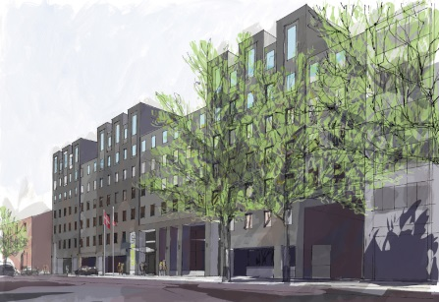

“Wakeup Copenhagen on Borgergade is an excellent choice for anyone looking for inexpensive accommodation in the heart of Copenhagen, with only 20 minutes to CBS with metro.

Modern, minimalist and stylish new budget hotel in Copenhagen. Designed by the famous Danish architect Kim Utzon. Wakeup Copenhagen Borgergade in the centre of Copenhagen is both architecturally striking and anyone with a penchant for design will enjoy staying at the beautiful hotel. The hotel is built in 2014.”

**Hotel Phoenix Copenhagen**

Bredgade 37

1260 Copenhagen K

+ 45 33 95 95 00

www.phoenixcopenhagen.dk

[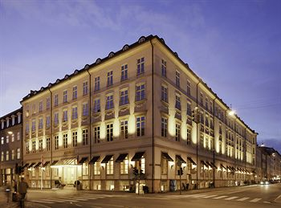](http://www.google.dk/url?sa=i&rct=j&q=&esrc=s&frm=1&source=images&cd=&cad=rja&uact=8&docid=iVeL7VYIPVFo4M&tbnid=DTvMyyhSu31T3M:&ved=0CAUQjRw&url=http://da.cityhotels.com/hotel-danmark/hotel-kobenhavn/phoenix-copenhagen/&ei=tDJ7U-DDNaqHyQP10YDgBQ&bvm=bv.67229260,d.bGQ&psig=AFQjCNEM1bTfJma1FKf6NnC4FfHGmIRnUQ&ust=1400669233620864)

“With its central and exclusive location in the heart of the old financial district, Hotel Phoenix is just minutes from Amalienborg Palace, Kongens Nytorv and the Royal Danish Theatre. There is only 20 minutes to CBS with metro.

The hotel’s décor takes its inspiration from the Louis XVI style with a touch of modern technology, and the incredibly elegant interior design is articulated throughout the hotel in beautifully appointed rooms and breath-taking suites.”

**CabInn Scandinavia**

Vodroffsvej 55

1900 Frederiksberg

+ 45 35 36 11 11

www.cabinn.com/københavn

[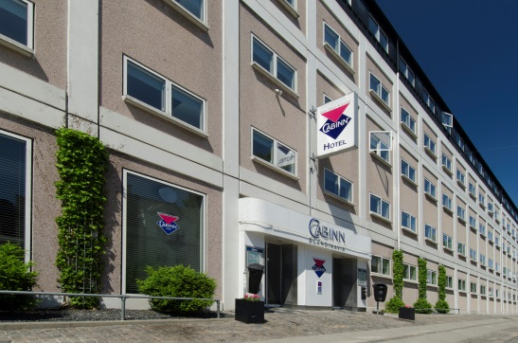](https://www.google.dk/url?sa=i&rct=j&q=&esrc=s&frm=1&source=images&cd=&cad=rja&uact=8&docid=Uj0jYdrKHA62mM&tbnid=Fr2POLsTjBCvhM:&ved=0CAUQjRw&url=https://www.cabinn.com/hotel/sca-hotel-koebenhavn-copenhagen&ei=F0J7U9juIfT7yAPk6IGYDw&bvm=bv.67229260,d.bGQ&psig=AFQjCNE6HOesWxp3nmr4hFhuWIScqx9_cw&ust=1400673169108710)

“CABINN Scandinavia Hotel is located in the peaceful borough of Frederiksberg, only 15 minutes away from CBS with metro. The hotel is close to the lakes and just a short walk from Town Hall Square, Strøget and Tivoli. Just around the corner, you will find the popular Forum concert venue and the Forum metro station.“